Test Case: tc002_SPX_Dev5_Crear_Requisicion_Spot_Tipo_Cobro_Project
Step 1 - Enter username and password and click to button Enter: Credentials Entered
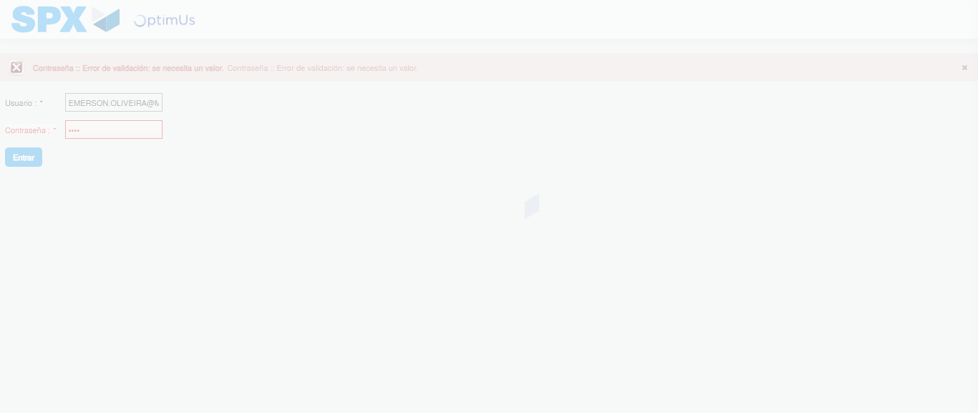Image file-name: QC_Testing-tc002_SPX_Dev5_Crear_Requisicion_Spot_Tipo_Cobro_Project-1784232428057

Step 2 - Select to UEN and Access to Spot Buy Requisitions : UEN Correctly selected and Correct access
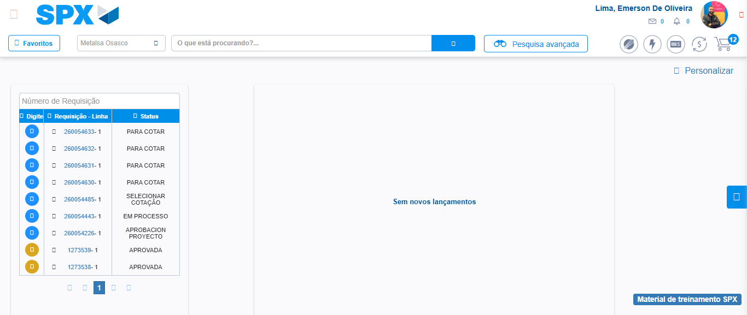Image file-name: QC_Testing-tc002_SPX_Dev5_Crear_Requisicion_Spot_Tipo_Cobro_Project-1784232475480

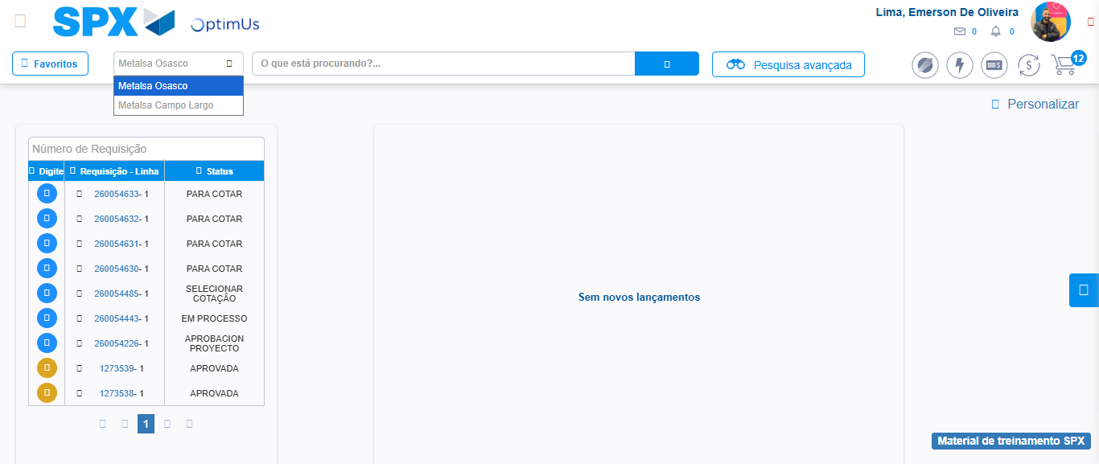Image file-name: QC_Testing-tc002_SPX_Dev5_Crear_Requisicion_Spot_Tipo_Cobro_Project-1784232477964

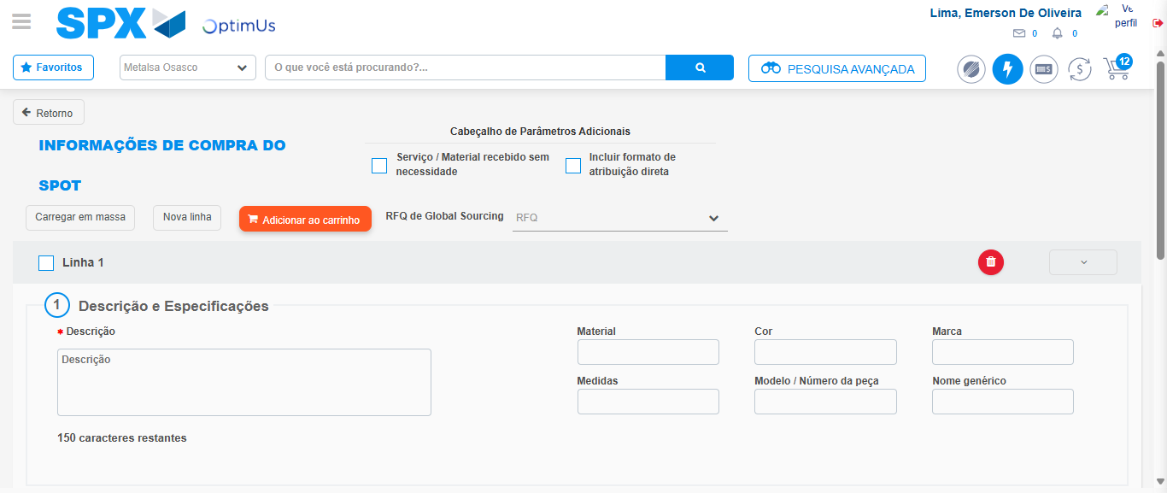Image file-name: QC_Testing-tc002_SPX_Dev5_Crear_Requisicion_Spot_Tipo_Cobro_Project-1784232486797

Step 3 - Data Capture Spot Buy Requisition: Data captured correctly
Image file-name: QC_Testing-tc002_SPX_Dev5_Crear_Requisicion_Spot_Tipo_Cobro_Project-1784232487067

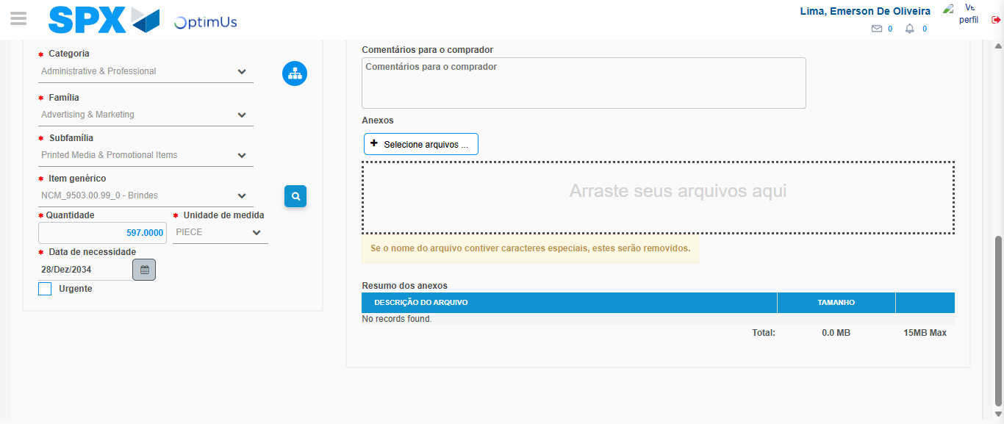Image file-name: QC_Testing-tc002_SPX_Dev5_Crear_Requisicion_Spot_Tipo_Cobro_Project-1784232537004

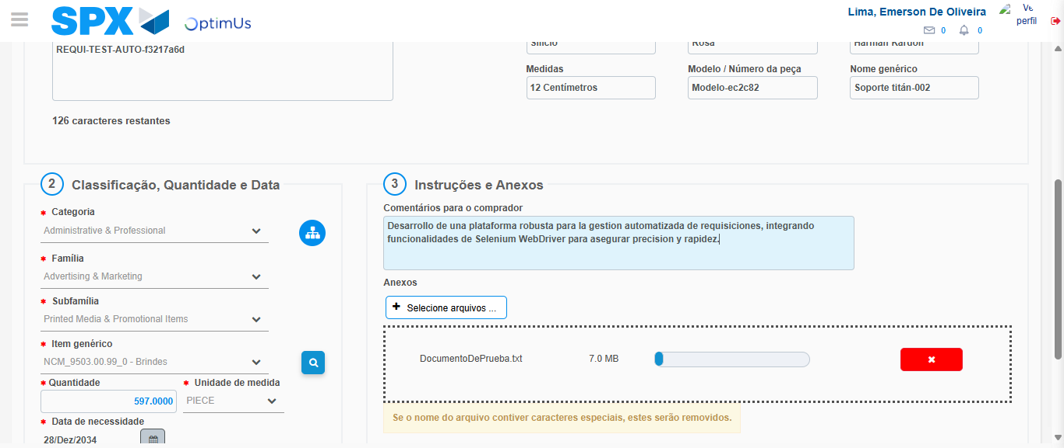Image file-name: QC_Testing-tc002_SPX_Dev5_Crear_Requisicion_Spot_Tipo_Cobro_Project-1784232537770

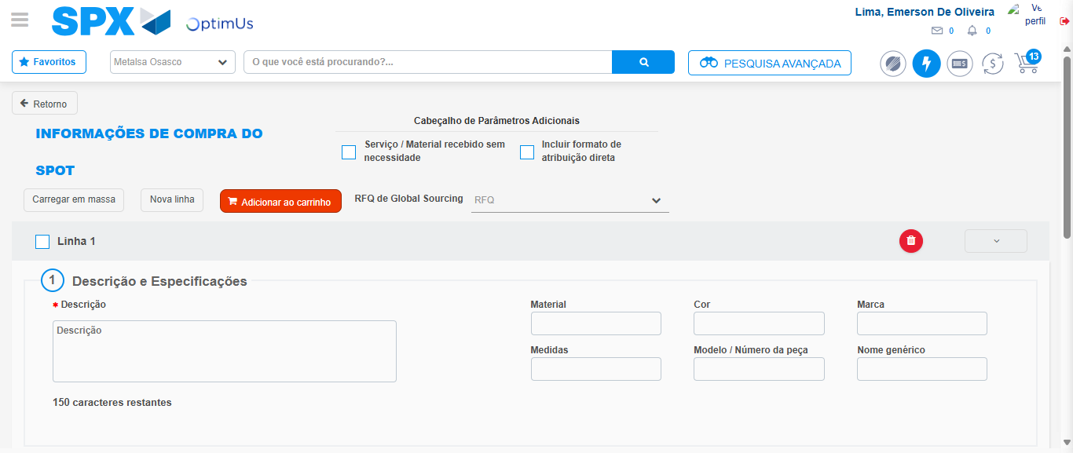Image file-name: QC_Testing-tc002_SPX_Dev5_Crear_Requisicion_Spot_Tipo_Cobro_Project-1784232542590

Step 7 - Return to Main Page SPX : Return to Main Page SPX
Image file-name: QC_Testing-tc002_SPX_Dev5_Crear_Requisicion_Spot_Tipo_Cobro_Project-1784232475480

Image file-name: QC_Testing-tc002_SPX_Dev5_Crear_Requisicion_Spot_Tipo_Cobro_Project-1784232477964

Image file-name: QC_Testing-tc002_SPX_Dev5_Crear_Requisicion_Spot_Tipo_Cobro_Project-1784232486797

Image file-name: QC_Testing-tc002_SPX_Dev5_Crear_Requisicion_Spot_Tipo_Cobro_Project-1784232544798

Image file-name: QC_Testing-tc002_SPX_Dev5_Crear_Requisicion_Spot_Tipo_Cobro_Project-1784232544967

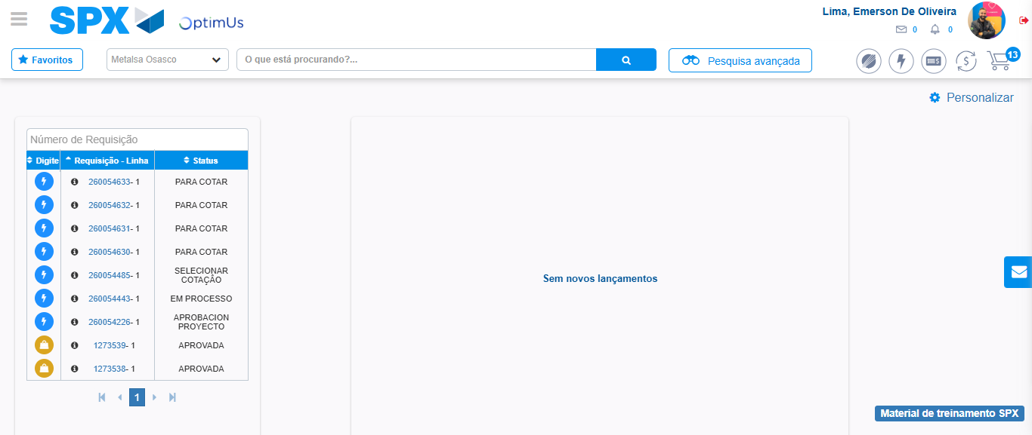Image file-name: QC_Testing-tc002_SPX_Dev5_Crear_Requisicion_Spot_Tipo_Cobro_Project-1784232566010

Step 8 - Log Out : Log Out SPX
Image file-name: QC_Testing-tc002_SPX_Dev5_Crear_Requisicion_Spot_Tipo_Cobro_Project-1784232566200

